**NANDHA ENGINEERING COLLEGE**

(An Autonomous Institution, Affiliated to Anna University, Chennai)

# ERODE–638052



## A Project Report

***Submitted by***

NANDHINI S M (23AI041)

*In partial fulfillment for the award of the degree*

*of*

# BACHELOR OF TECHNOLOGY

# IN

# ARTIFICIAL INTELLIGENCE AND DATA SCIENCE

**DEPARTMENT OF ARTIFICIAL INTELLIGENCE AND**

**DATA SCIENCE**

What is Tableau?

Tableau is a powerful and easy-to-use data visualization tool that helps people understand data.  
It allows users to create beautiful charts, dashboards, and reports without needing to write complex code.  
With Tableau, we can turn raw data into clear, interactive visual stories to find trends, patterns, and insights.  
It is widely used in businesses, research, and education to make better decisions by seeing data visually.

Project: CRIME INCIDENT ANALYSIS 2024

This project is a **Crime Incident Analysis Dashboard** created using **Tableau**.  
 The main goal of the project is to **analyze crime data** reported in the year 2024.  
 It focuses on **different types of crimes** (like Assault, Robbery, Burglary) and organizes them by **shift** (Day, Evening, Midnight).

* Number of crimes per shift
* Maximum and minimum incidents reported in different census tracts (areas)
* Comparison across offense types

Steps in the Project:

1. Connect Tableau to the car sales data (from an Excel file or database).
2. Clean the data if needed (remove errors or missing values).
3. Create visualizations like bar charts, pie charts, line graphs, and maps.
4. Build dashboards that combine different charts together.
5. Analyze the dashboards to find patterns, trends, and useful insights.

Importance of This Project:

This project helps identify crime patterns based on time and offense type.  
It supports better resource planning and police deployment.  
It enables data-driven decision-making for public safety improvements.  
It makes crime insights easy to understand through clear visualizations.

## MEASURES:

## 

## 

### **What This Chart Shows:**

1. It displays crime offenses (like ARSON, BURGLARY) by shift (DAY, EVENING, MIDNIGHT).
2. It shows three measures for each: Census Tract value, Maximum, and Minimum incidents.
3. "Census Tract" is the number of incidents recorded.
4. "MAXIMUM" and "MINIMUM" show the highest and lowest incident counts across areas.

## How We Built It:

1. Drag Offense and Shift into the Rows shelf.
2. Drag Census Tract into the view multiple times for SUM, MAX, and MIN values.
3. Set aggregation types (SUM for Census Tract, MAX for Maximum, MIN for Minimum).
4. Choose the Text Table type from Show Me to present it neatly.

## MAXIMUM METHOD OF CRIME:

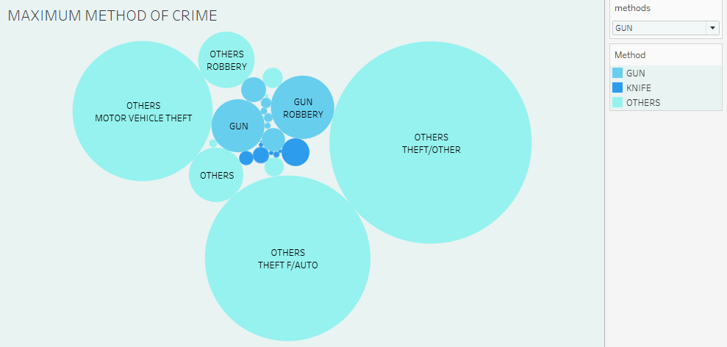

## What This Chart Shows:

1. It shows the maximum number of crimes based on the method used (Gun, Knife, Others).
2. The size of each bubble represents the volume of crimes — bigger bubble = more crimes.
3. Different colors represent different crime methods (blue for Gun, light blue for Others, etc.).
4. The filter on the right allows users to select a method (like Gun) and view only related crime types.

## How We Built It:

* Use a Bubble Chart by dragging a Dimension (like Offense Type) to Label and a Measure (crime count) to Size.
* Drag Method to Color to differentiate bubbles by crime method (Gun, Knife, Others).
* Add a Filter for Method on the right side so users can choose the method they want to analyze.
* Format the chart (background color, bubble transparency) to make it clean and visually appealing.

**HIGH CASES BASED ON SHIFT:**

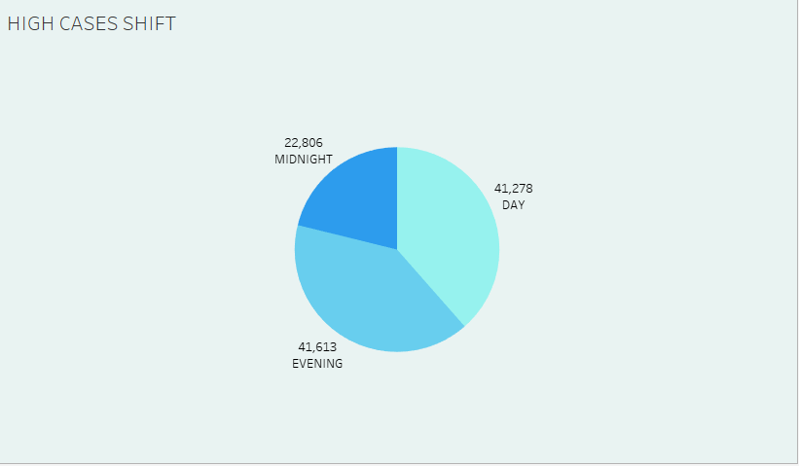

What This Chart Shows:

1. It shows the distribution of crime cases across different shifts: Day, Evening, and Midnight.
2. Each section of the pie chart represents the number of crimes reported in that shift.
3. Evening has the highest number of cases (41,613), slightly more than Day (41,278).
4. The size of each slice is proportional to the number of incidents — bigger slice = more cases.

.

How We Built It:

1. Drag the Shift field to Columns or Rows, and Number of Cases to Angle and Label.
2. Select Pie Chart from the Marks dropdown

WARD HAVING HIGHEST CRIME RATE:

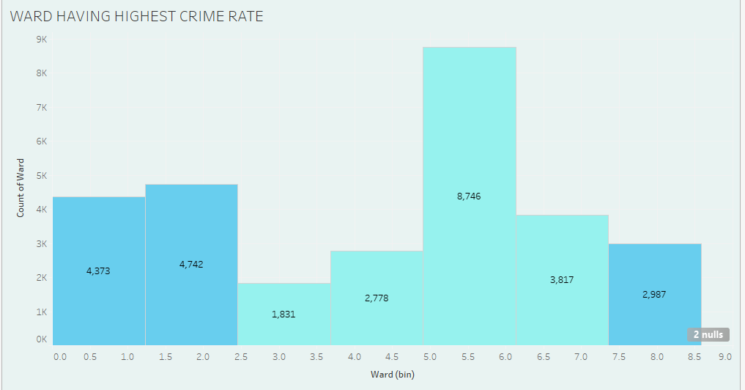

What This Chart Shows:

1. It shows the crime counts across different ward bins (ward numbers grouped into ranges).
2. Each bar represents the number of crimes reported in that ward range.
3. The highest crime rate is seen in wards around 5–6, with 8,746 cases.
4. The height of each bar corresponds to the count of wards with high crime rates.

How We Built It:

1. Bin the Ward field (create bins, e.g., 0–1, 1–2, etc.) to group ward numbers.
2. Drag Ward (bin) to the Columns shelf and Count of Ward to the Rows shelf.
3. Choose a Bar Chart from the Marks dropdown menu.
4. Add labels on bars to show the number of cases and format it with colors for clarity.

**MONTH OF MOST CRIMES:**

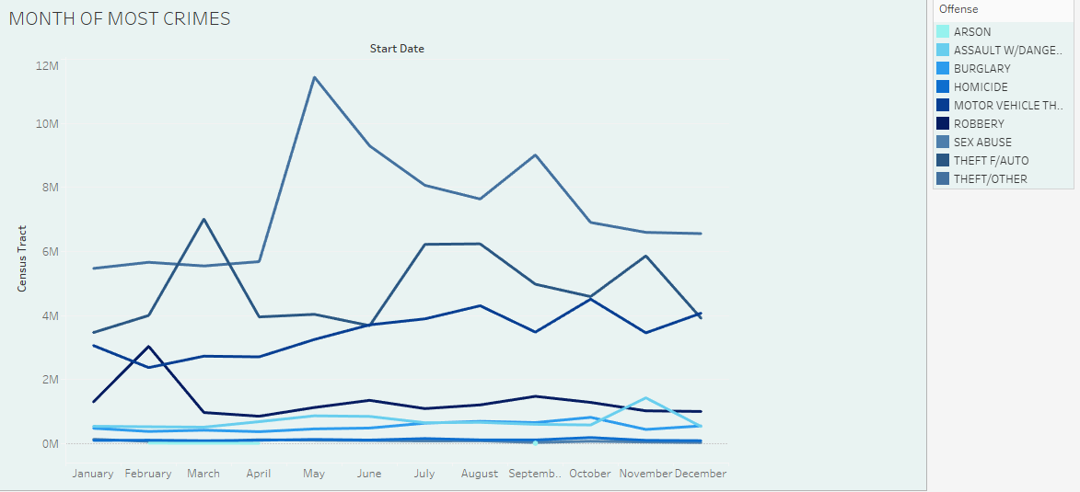

What This Grid Shows:

1. This line chart shows the trend of crimes across each month from January to December.
2. Each line represents a different offense type (like Robbery, Motor Vehicle Theft, etc.).
3. The Y-axis represents the Census Tract count (number of crimes), and the X-axis is the month.
4. It helps identify which months saw spikes or drops in specific types of crimes — for example, a huge spike around May.

How We Built It:

1. Drag Start Date (Month) to the Columns shelf and Census Tract (count) to the Rows shelf.
2. Add Offense to the Color shelf to differentiate lines.
3. Select Line Chart as the visualization type.
4. Use filtering or highlighting to focus on particular crime types if needed.

**FINDING TRENDS:**

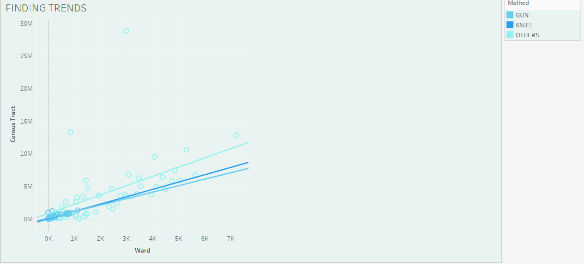

WHAT THIS CHART SHOWS:

1. This is a scatter plot showing the relationship between Ward and Census Tract.
2. The dots represent individual incidents, categorized by the Method (Gun, Knife, Others).
3. The trend lines (one for each method) show the general direction or pattern: as Ward numbers increase, the number of Census Tracts related to incidents increases too.
4. Lighter colors (like light blue) indicate different methods are compared easily for trend analysis.

HOW WE BUILT IT:

1. Drag Ward to the Columns shelf and Census Tract to the Rows shelf.
2. Add Method to the Color shelf.
3. Change the Marks type to Circle.
4. Add a Trend Line for each Method (Analyze → Trend Lines → Show Trend Lines).

**WHICH CLUSTER HAS HIGHEST CRIME RATE:**

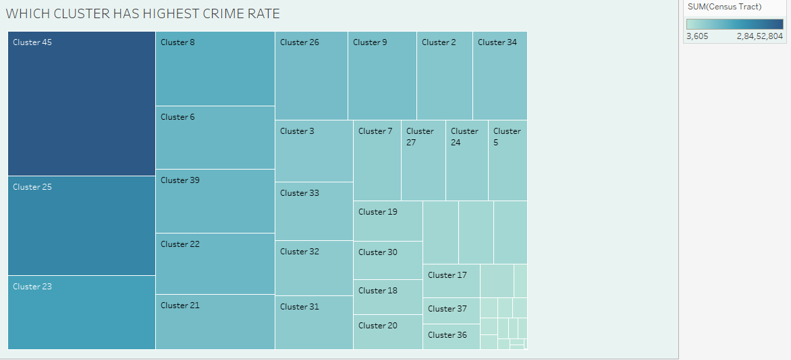

WHAT THIS CHART SHOWS:

1. It is a Tree Map visualization.
2. Each rectangle shows a different Cluster.
3. Size and color represent total crime rates.
4. Cluster 45 has the highest crime rate.

HOW WE BUILT IT:

1. Chose a Tree Map chart type (likely in Tableau).
2. Set Cluster as the Dimension.
3. Set Sum of Census Tract as the Measure.
4. Applied color gradient based on crime rate values.

**REPORT OF EVERY OFFENSE WITH CCN:**

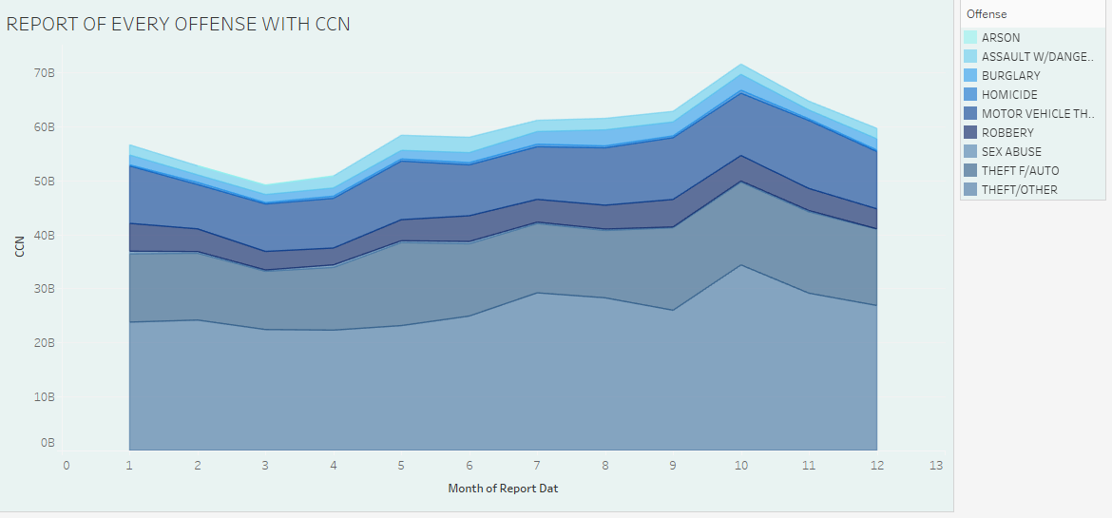

WHAT THIS CHART SHOWS:

1. This is a Stacked Area Chart.
2. It shows different offenses (like Arson, Burglary, Robbery, etc.) over months.
3. The y-axis (CCN) represents the count of cases reported.
4. Theft-related offenses occupy the largest area, meaning they happen the most.

## HOW WE BUILT IT:

1. Selected a Stacked Area Chart type (most likely in Tableau).
2. Plotted Month of Report Date on the x-axis.
3. Plotted CCN (case numbers) on the y-axis.
4. Used Offense type for color coding and stacking different crimes.

**DASHBOARDS:**

DASHBOARD 1:

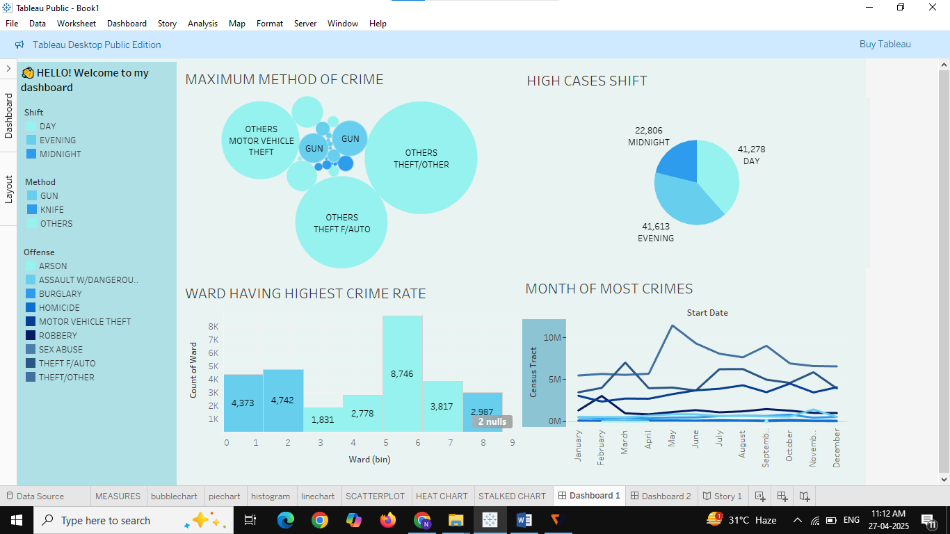

DASHBOARD 2:

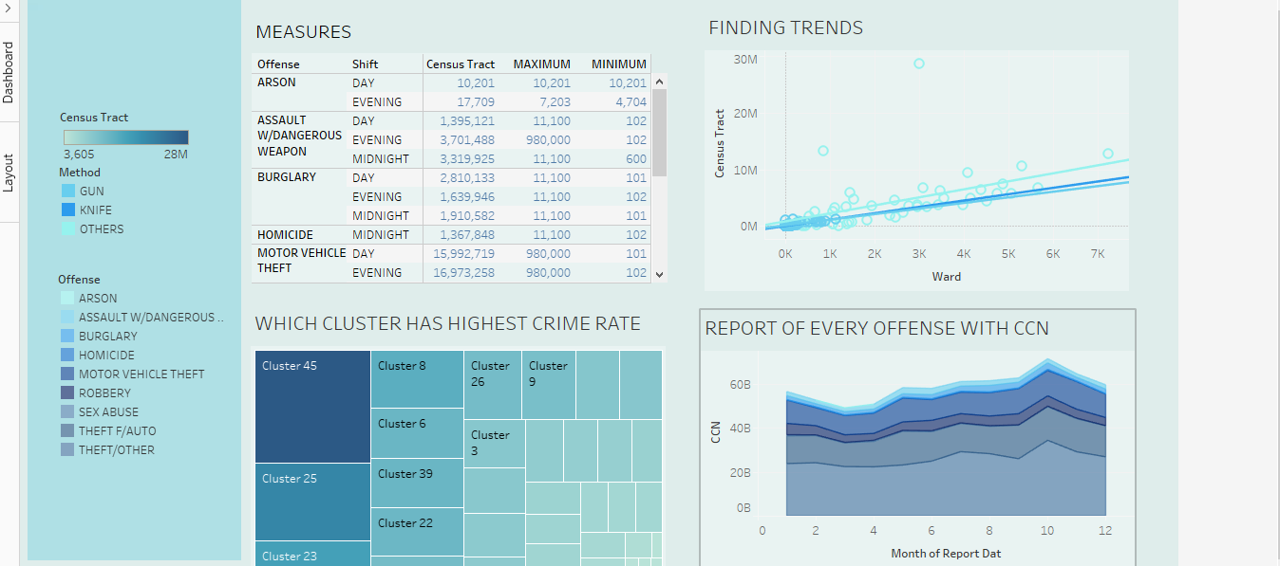

# ****Project Overview: Crime Incidents Analysis 2024****

### **Objective:**

Analyze crime incident data for 2024 to identify crime patterns, high-risk clusters, and offense trends over time.

### **Dataset:**

* File: **Crime_Incidents_in_2024.csv**
* Fields likely include: **Cluster ID, Offense Type, Report Date, CCN (case numbers), Census Tract data**.

### **Key Visualizations:**

1. **Treemap** – Identified the **cluster with the highest crime rate** (Cluster 45).
2. **Stacked Area Chart** – Showed the **trend of various offenses** (e.g., Theft, Burglary) across different months.

### **Insights:**

* **Cluster 45** reported the most crimes.
* **Theft-related crimes** were consistently high throughout the year.
* Crime counts **peaked around the 10th month** (October).